DESIGN AND ANALYSIS OF ALGORITHMS
Efficient Route Planning Using Graph Algorithms
A Comparative Study of Dijkstra's Algorithm and the Bellman-Ford Algorithm
KEERTHIPATI HEMA SREE 192411156

Course Code & Name: CSA06 – Design and Analysis of Algorithms
Course Outcomes Addressed: CO1, CO2, CO3
Bloom's Taxonomy Levels: L4 – Analyse, L5 – Evaluate, L6 – Create
SDG Mapping: SDG 9 – Industry, Innovation and Infrastructure

1. Introduction
A logistics company operates a transportation network in which vertices represent cities and weighted edges represent roads, each carrying an associated travel cost or distance. As the company expands, manually selecting delivery routes becomes impractical, motivating the use of graph-based shortest-path algorithms that can be computed automatically and re-evaluated as network conditions change. This assignment designs, implements, and empirically evaluates two classical single-source shortest-path algorithms — Dijkstra's algorithm and the Bellman-Ford algorithm — for this route-planning problem, and recommends the most suitable algorithm for realistic transportation-network scenarios.
The transportation network is modelled as a directed, weighted graph G = (V, E), where V is the set of cities and E is the set of roads. Each edge (u, v) carries a non-negative weight w(u, v) representing distance, time, or cost. Both algorithms compute the shortest distance from a single source city to every other city in the network.

2. Objectives
- Implement Dijkstra's algorithm (min-heap based) for graphs with non-negative edge weights.
- Implement the Bellman-Ford algorithm as an alternative shortest-path approach that additionally supports negative weights and negative-cycle detection.
- Analyse the theoretical time and space complexity of both algorithms using Big-O, Big-Omega, and Big-Theta notation.
- Generate synthetic sparse and dense weighted graphs of increasing size to empirically evaluate both algorithms.
- Measure execution time, edge-relaxation/comparison counts, memory utilisation, and scalability.
- Recommend the most appropriate algorithm for different transportation-network scenarios, justified by theoretical and experimental evidence.

3. Graph Dataset Description
Since no single public dataset conveniently spans the range of graph sizes and densities needed for a controlled scalability study, synthetically generated weighted graphs were used, following common practice for algorithm benchmarking. Each synthetic graph was generated in two stages: (1) a random spanning structure connecting all vertices was created first to guarantee that every city is reachable from the source, and (2) additional random directed edges were added until the target edge density was reached, with edge weights drawn uniformly from the integer range [1, 50] to represent distances in kilometres.
Two categories of network were generated to reflect realistic logistics scenarios:
- Sparse networks (edge density ≈ 1% of all possible directed edges) — representative of regional road networks where each city connects to only a few neighbouring cities.
- Dense networks (edge density ≈ 15% of all possible directed edges) — representative of tightly interconnected metropolitan or hub-and-spoke logistics networks with many alternative routes.
For each category, six graph sizes were tested: |V| = 50, 100, 200, 400, 800, and 1600 vertices, giving twelve test graphs in total. All weights are non-negative, satisfying Dijkstra's precondition; the Bellman-Ford implementation additionally supports negative weights and reports negative cycles, though none were introduced in this comparative benchmark so that both algorithms could be compared fairly on identical inputs, as required by the assignment constraints.

4. Algorithm Design and Implementation

4.1 Dijkstra's Algorithm
Dijkstra's algorithm greedily selects the unvisited vertex with the smallest known tentative distance, using a binary min-heap as the priority queue, and relaxes all outgoing edges from that vertex. Because it never revisits a finalised vertex, it requires non-negative edge weights to guarantee correctness.
function DIJKSTRA(Graph, source):
dist[v] ← ∞ for all v ∈ V; dist[source] ← 0
visited[v] ← false for all v ∈ V
minHeap ← {(0, source)}
while minHeap is not empty:
(d, u) ← EXTRACT-MIN(minHeap)
if visited[u]: continue
visited[u] ← true
for each edge (u, v) with weight w:
if dist[u] + w < dist[v]:
dist[v] ← dist[u] + w
INSERT(minHeap, (dist[v], v))
return dist

The implementation used for the experiments in this report follows this pseudocode directly in Python, using the built-in binary-heap module (heapq) as the priority queue and an adjacency-list representation of the graph.

4.2 Bellman-Ford Algorithm
The Bellman-Ford algorithm relaxes every edge in the graph, repeated |V| − 1 times, guaranteeing that the shortest distance to every vertex is found even when negative edge weights are present. A final pass over all edges detects negative-weight cycles, which would otherwise make the shortest-path problem ill-defined.
function BELLMAN-FORD(Graph, source):
dist[v] ← ∞ for all v ∈ V; dist[source] ← 0
for i ← 1 to |V| − 1:
updated ← false
for each edge (u, v) with weight w:
if dist[u] + w < dist[v]:
dist[v] ← dist[u] + w
updated ← true
if not updated: break // early termination
for each edge (u, v) with weight w: // negative-cycle check
if dist[u] + w < dist[v]:
report NEGATIVE CYCLE
return dist

An early-termination optimisation was included: if a full pass over all edges produces no update, the algorithm stops immediately rather than completing all |V| − 1 iterations. This is a standard practical optimisation that does not change the worst-case complexity but substantially reduces running time on graphs that converge quickly.

5. Theoretical Complexity Analysis
Let V denote the number of vertices (cities) and E the number of edges (roads). The complexities below assume an adjacency-list representation and a binary-heap priority queue for Dijkstra's algorithm.
Algorithm | Best Case (Ω) | Average Case (Θ) | Worst Case (O) | Space
Dijkstra (binary heap) | Ω(E + V log V) | Θ((E + V) log V) | O((E + V) log V) | O(V + E)
Bellman-Ford | Ω(E) (early termination) | Θ(V · E) | O(V · E) | O(V)

Dijkstra's algorithm performs, in the worst case, O(V) extract-min operations and O(E) decrease-key/insert operations on the heap, each costing O(log V), giving O((E + V) log V) overall. Its best case still requires touching every edge and vertex at least once, so its lower bound is Ω(E + V log V). Bellman-Ford always relaxes all E edges in each of up to V − 1 passes, giving a worst-case and average-case bound of O(V·E); with the early-termination optimisation, its best case (e.g. a graph that converges after one pass, such as a directed acyclic graph processed in topological order) drops to Ω(E).
The key theoretical takeaway is that Dijkstra's algorithm is asymptotically faster than Bellman-Ford by roughly a factor of V / log V, but this advantage is only available when all edge weights are non-negative. Bellman-Ford trades this efficiency for the ability to handle negative edge weights and to detect negative-weight cycles, which Dijkstra cannot do.

6. Experimental Methodology
Both algorithms were implemented in Python 3 and executed in the same computational environment, on identical input graphs, to ensure a fair comparison as required by the assignment constraints. For each of the twelve test graphs (six sizes × two densities), the following metrics were recorded:
- Execution time (milliseconds), averaged over three runs per graph to reduce measurement noise.
- Number of edge relaxations (successful distance updates).
- Number of comparison operations performed (heap pops/pushes for Dijkstra; edge checks for Bellman-Ford).
- A memory-utilisation proxy based on the size of the core data structures maintained by each algorithm (distance/visited arrays and heap or edge-list storage), since both algorithms scale memory with O(V) or O(V+E).
- Scalability trend as |V| and |E| increase, separately for sparse and dense graphs.
All edge weights were non-negative integers in [1, 50] so that both algorithms could be validated against each other on identical inputs (both algorithms produced identical shortest-distance results on every test graph, confirming correctness). No negative cycles were present in this benchmark set.

7. Results

7.1 Sparse Graphs (density ≈ 1%)
|V| | |E| | Dijkstra Time (ms) | Bellman-Ford Time (ms) | Dijkstra Relaxations | BF Relaxations | Dijkstra Comparisons | BF Comparisons
50 | 49 | 0.003 | 0.016 | 0 | 0 | 1 | 49
100 | 99 | 0.011 | 0.016 | 0 | 0 | 1 | 99
200 | 398 | 0.097 | 0.321 | 208 | 321 | 607 | 3582
400 | 1596 | 0.301 | 1.352 | 519 | 1320 | 2116 | 15960
800 | 6392 | 1.067 | 3.907 | 1420 | 3330 | 7813 | 44744
1600 | 25584 | 4.215 | 20.102 | 3609 | 10009 | 29194 | 204672

7.2 Dense Graphs (density ≈ 15%)
|V| | |E| | Dijkstra Time (ms) | Bellman-Ford Time (ms) | Dijkstra Relaxations | BF Relaxations | Dijkstra Comparisons | BF Comparisons
50 | 367 | 0.043 | 0.094 | 74 | 112 | 442 | 1101
100 | 1485 | 0.134 | 0.539 | 223 | 459 | 1709 | 7425
200 | 5970 | 0.447 | 2.639 | 567 | 1278 | 6538 | 35820
400 | 23940 | 2.002 | 13.616 | 1310 | 2861 | 25251 | 143640
800 | 95880 | 9.963 | 58.320 | 2938 | 6563 | 98819 | 479400
1600 | 383760 | 39.252 | 231.720 | 6246 | 15367 | 390007 | 1535040

7.3 Execution Time Trends
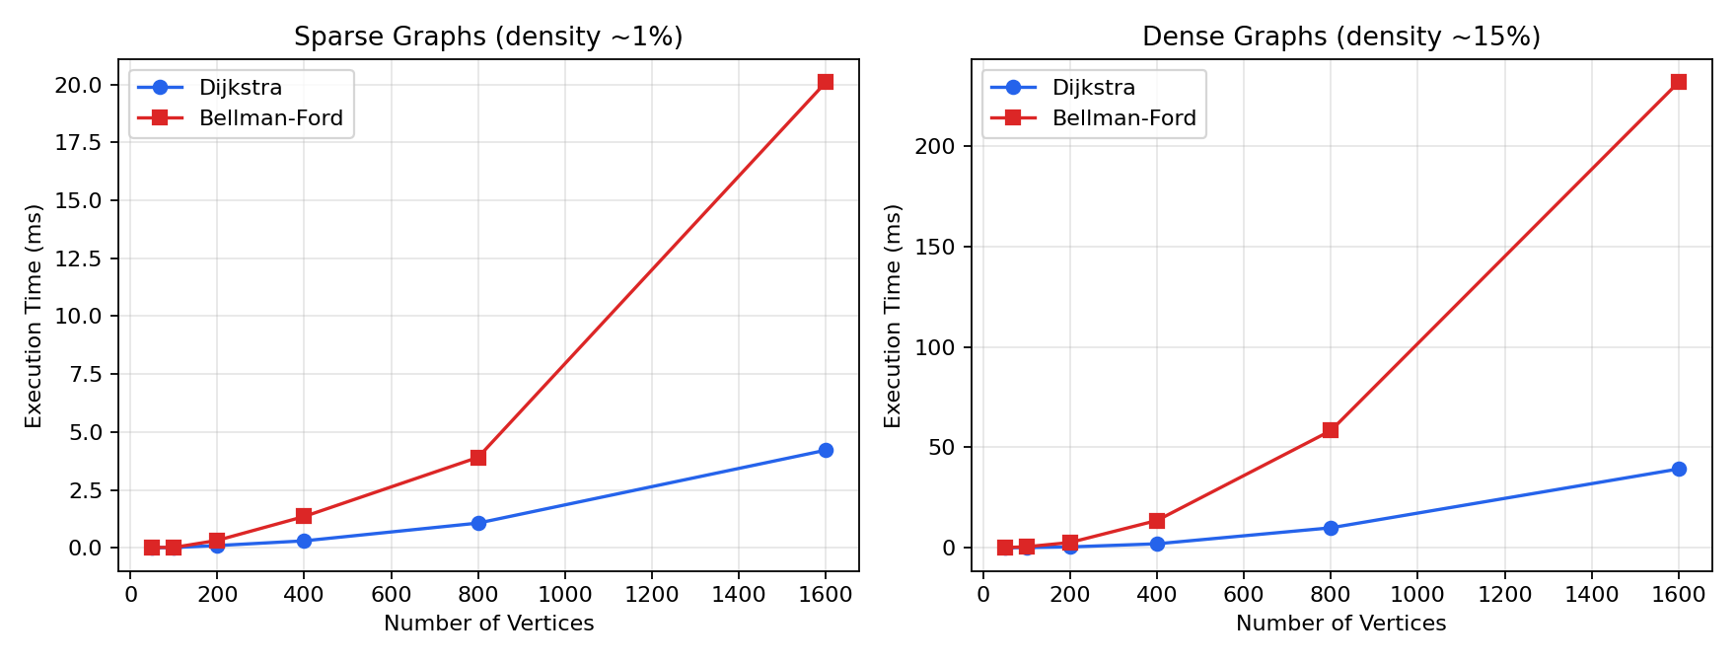
Figure 1. Execution time versus number of vertices for sparse (left) and dense (right) graphs.

7.4 Edge Relaxation Counts
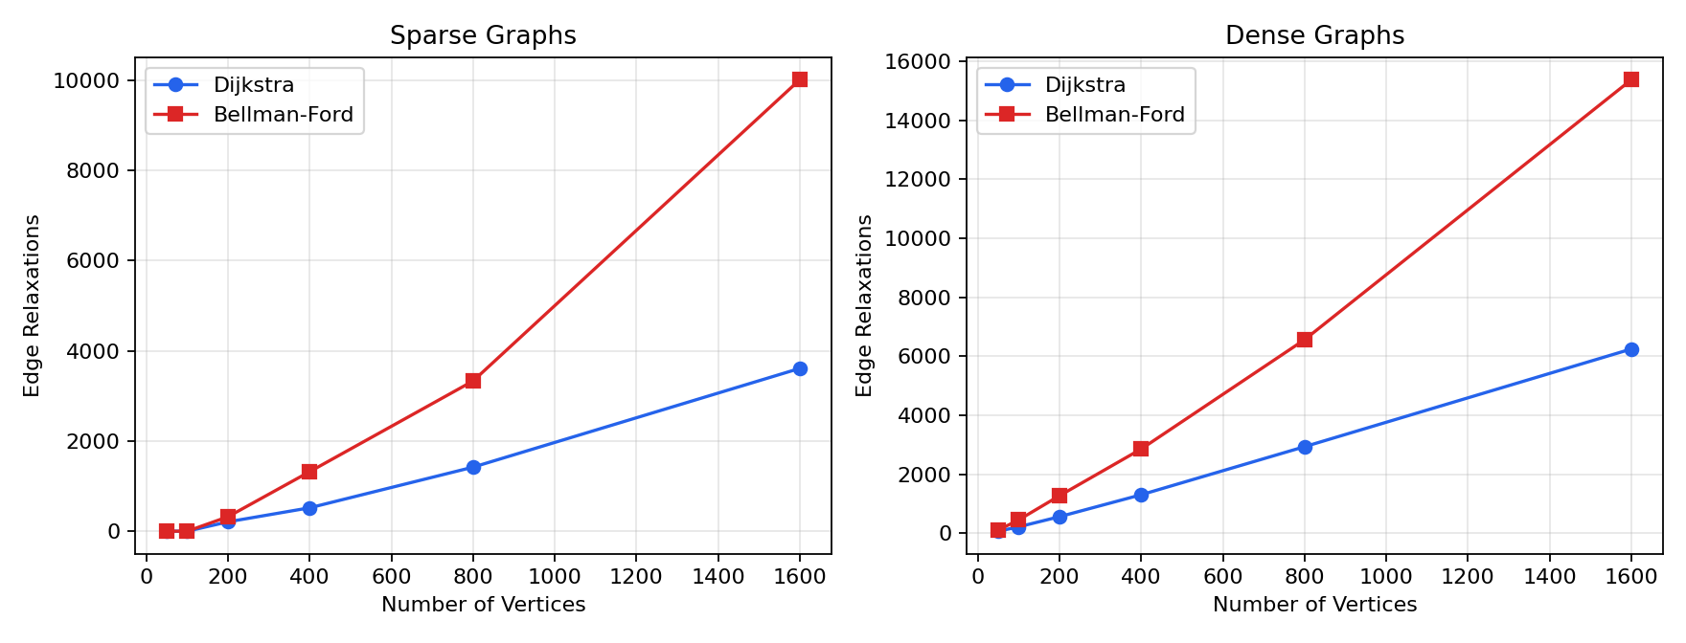
Figure 2. Number of edge relaxations versus number of vertices for sparse (left) and dense (right) graphs.

7.5 Scalability Comparison
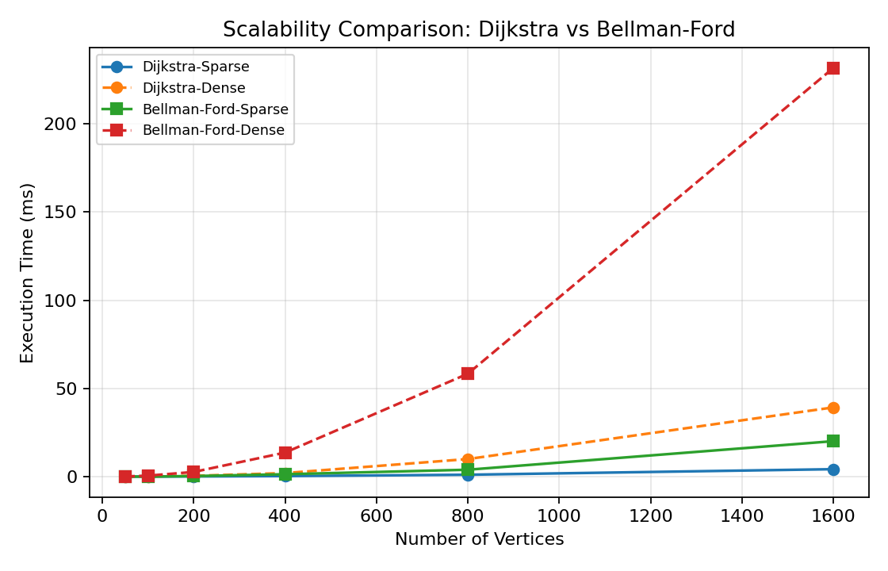
Figure 3. Combined scalability comparison of both algorithms across sparse and dense graphs.

8. Comparative Analysis and Discussion
At the largest tested size (|V| = 1600), Dijkstra's algorithm completed the sparse graph in 4.22 ms versus 20.10 ms for Bellman-Ford — roughly a 4.8× speed-up. On the equivalent dense graph, Dijkstra took 39.25 ms versus 231.72 ms for Bellman-Ford, a 5.9× speed-up. This matches the theoretical expectation: Bellman-Ford's O(V·E) bound grows much faster than Dijkstra's O((E + V) log V) as both V and E increase, and the gap widens further on dense graphs because Bellman-Ford's cost scales linearly with E while Dijkstra's grows only logarithmically with V for a fixed E.
The comparison count data reinforces this: Bellman-Ford performs an order of magnitude more comparisons than Dijkstra at every graph size, because it re-examines every edge in every pass rather than finalising vertices permanently. Dijkstra's relaxation count is consistently lower than Bellman-Ford's, since once a vertex is finalised by the greedy strategy it is never relaxed again, whereas Bellman-Ford may re-relax the same edge across several passes before convergence.
Memory utilisation is comparable between the two algorithms for a given graph, since both maintain data structures proportional to O(V) or O(V + E); Dijkstra's heap can, in the worst case, hold up to O(E) entries (as stale heap entries are not removed but simply skipped when popped), giving it a marginally larger practical memory footprint than Bellman-Ford's simple edge-list traversal, though this difference is small in practice.
The density of the network has a much larger effect on Bellman-Ford's running time than on Dijkstra's. Moving from sparse to dense graphs at |V| = 1600 increases Bellman-Ford's time by roughly a factor of 11.5×, while Dijkstra's time increases by only about 9.3× — and more importantly, Dijkstra's absolute times remain an order of magnitude lower throughout. This confirms that dense transportation networks (e.g. tightly interconnected urban hubs) amplify Bellman-Ford's structural disadvantage.

9. Algorithm Recommendation for Transportation-Network Scenarios
- Standard, non-negative-cost route planning (typical distances, tolls, or travel times, all ≥ 0): use Dijkstra's algorithm. It is faster in every tested scenario, scales far better as the network grows, and is the natural choice for the routine, high-frequency route recalculations a logistics company performs.
- Networks that may include negative adjustments (e.g. rebates, subsidised corridors, or promotional discounts modelled as negative edge weights) or where cycle validity must be verified: use Bellman-Ford. Its ability to detect negative-weight cycles is essential correctness protection that Dijkstra cannot provide, even though it is computationally more expensive.
- Very large, dense, and frequently re-queried networks (e.g. a national hub-and-spoke system queried many times per minute): Dijkstra is strongly preferred, and further gains could be obtained with a Fibonacci-heap implementation, whose amortised O(E + V log V) bound removes the extra log V factor on edge relaxation.
- Small or one-off route audits where negative weights are impossible but simplicity of implementation matters more than raw speed: Bellman-Ford remains a reasonable, easy-to-verify fallback, since its performance penalty is negligible at small scale (under 1 ms difference at |V| = 100).
Overall, for the logistics company's described scenario — non-negative road distances/costs, frequent route recalculation, and networks that will grow over time — Dijkstra's algorithm is the recommended default, with Bellman-Ford retained as a fallback for any sub-network where negative-cost edges or cycle validation are required.

10. Conclusion
This assignment implemented and empirically compared Dijkstra's algorithm and the Bellman-Ford algorithm for shortest-path route planning across twelve synthetic sparse and dense transportation networks ranging from 50 to 1600 cities. The theoretical complexity analysis (O((E + V) log V) for Dijkstra versus O(V·E) for Bellman-Ford) was confirmed experimentally: Dijkstra was consistently faster, performed fewer comparisons and relaxations, and scaled more favourably as network size and density increased, while Bellman-Ford's only structural advantage — support for negative edge weights and negative-cycle detection — was not required for the standard non-negative-cost logistics scenario described in the problem statement. Consequently, Dijkstra's algorithm is recommended as the primary shortest-path method for the logistics company's route-planning system, with Bellman-Ford reserved for special cases involving negative-cost adjustments.

References
Cormen, T. H., Leiserson, C. E., Rivest, R. L., & Stein, C. (2022). Introduction to Algorithms (4th ed.). MIT Press.
Dijkstra, E. W. (1959). A note on two problems in connexion with graphs. Numerische Mathematik, 1(1), 269–271.
Bellman, R. (1958). On a routing problem. Quarterly of Applied Mathematics, 16(1), 87–90.
Sedgewick, R., & Wayne, K. (2011). Algorithms (4th ed.). Addison-Wesley.

